Start Time | Activity | Minutes
X:00 | - Any questions before the quiz? | 0-10
X:00 | - Quiz 3 | 20
X:00 | - Collect Quizzes | 2
X:00 | - Announcements  - Week 3  - Reminder: Math Lab, Friend in class, Office Hours, etc.  - How’s homework going?  - Any questions? | 3
X:00 | - My guesses about what we would cover last week were totally wrong lol. I'm going to email him to see if he knows in advance what he's going to cover, when.  - We covered 4.1 through 4.4 and 6.1 through 6.2 | 3
X:00 | 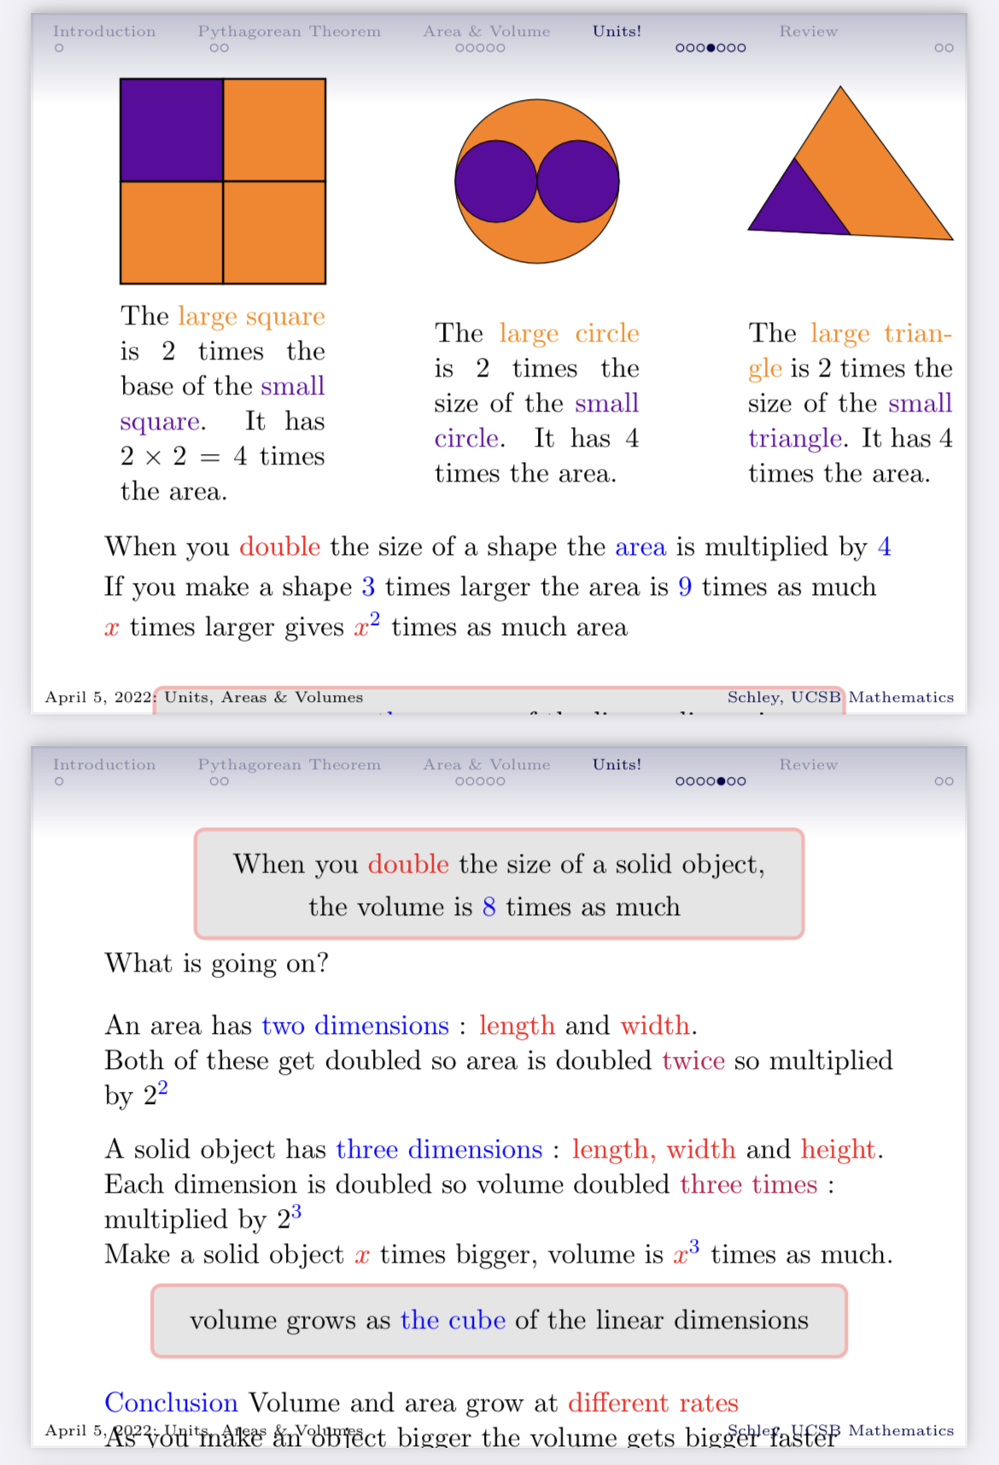
X:00 | 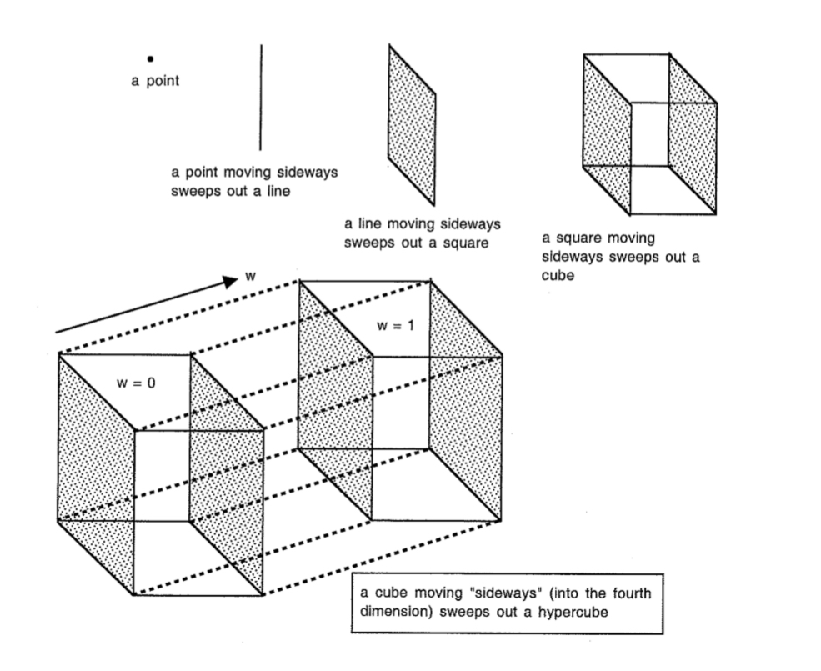
X:00 | 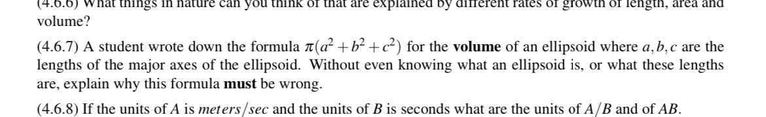
X:00 | - Questions from HW / More group practice
X:00
X:00
X:00
X:00
X:00
X:00
X:00

